**Advertising Web design & development businesses**

**How to get started**

[Hugo Organista](https://www.godaddy.com/garage/author/horganista/) November 18, 2019

Web design promotion ideas

Keeping your project pipeline filled can prove to be a daunting task for many web designers, given that it requires you to prospect, qualify and close deals — all while partaking in the balancing act of business ownership. That’s why advertising web design services consistently is a must.

**A sure way to keep your list of clients growing is to keep prospecting potential customers with the help of an effective advertising campaign.**

There are various methods you can use to promote your web design services, and this article will cover a handful of them that you can start using right away to get more clients for your business.

*Related:*[*How to get web design clients, fast*](https://www.godaddy.com/garage/get-web-design-clients-fast/)

**Try these ideas for advertising your web design & development business**

These methods can work for various types of businesses, but today we will focus on web design advertising ideas to help you get more web design clients.

**The more efficient you can get at advertising, the more clients you will get, and the better your business can run.**

It’s important to keep in mind who your target audience is and the type of projects you are trying to capture through advertising.

Here’s what we’re going to cover:

* [**Tap into a larger network on social media**](https://www.godaddy.com/garage/advertising-web-design-development-business/#social-media)**.**
* [**Laser-target your customers with paid advertising**](https://www.godaddy.com/garage/advertising-web-design-development-business/#paid-advertising)**.**
* [**Be everywhere with online local business directory listings**](https://www.godaddy.com/garage/advertising-web-design-development-business/#local-business)**.**
* [**Diversify your clientele by advertising on websites for freelance projects**](https://www.godaddy.com/garage/advertising-web-design-development-business/#diversify)**.**
* [**Pair your website with SEO for a strong advertising strategy**](https://www.godaddy.com/garage/advertising-web-design-development-business/#seo)**.**
* [**Generate leads offline by advertising through business relationships**](https://www.godaddy.com/garage/advertising-web-design-development-business/#leads)**.**
* [**Go old-school with referrals and print ads**](https://www.godaddy.com/garage/advertising-web-design-development-business/#print-ads)**.**

Each business is different, and not all of these tactics will work for everyone. Try a combination of each of these web design promotion ideas and with time, you will find the ones that provide the most value for your business.

**Tap into a larger network on social media**



Social media is great for connecting with friends and family, but it’s also a great way to get the word out about your web design services.

Sites like Facebook, Instagram and even LinkedIn are all great channels you can use to your benefit and to find new prospects for your business, and stay in touch with them even after your  
projects are finished.

**A great way to get people asking about your services is to share your completed or current works with your social media network.**

Providing a brief description of your role and involvement in a project can show new potential clients that you’re authentic and it gives them an opportunity to learn more about your business and skills.

Best of all, posting on social media is a relatively low-cost method to reach people. Learn more about boosting your posts every once in a while to reach your targeted audience.

Another great way to get more eyes on your work through social media is to ask your immediate friends and family to share your posts on their social pages. Potential clients are more likely to contact you for services if someone else is recommending you, even if it’s online!

*Related:*[*Beginner’s social media guide*](https://www.godaddy.com/garage/a-beginners-guide-to-social-media-for-small-business)

[**Back to top**](https://www.godaddy.com/garage/advertising-web-design-development-business/#top)

**Laser-target your customers with paid advertising**

Did you know that small business owners say that they earn [$3 for every $1.60 that they spend on Google Ads](https://www.powertraffick.com/ppc-trends-and-statistics)?

**Paid digital advertising is another great way to advertise your web design services to new clients.**

Advertising platforms from Google and Facebook allow you to designate a budget and even choose who you want to show your ads to. The accurate targeting methods of these large platforms allow you to reach your exact potential customer with a few clicks.

You can use Facebook and Google’s advertising platforms to your advantage, as Facebook’s ad platform is a great way to target groups of people who are interested in specific categories and topics, while Google’s platform is intent-based.

An [intent-based ad platform](https://blog.smalldogcreative.com/interests-vs-intent-comparing-facebook-advertising-and-google-adwords/) is beneficial because it means that someone is actively searching for a service or business like yours, and has an active intent to find more information.

On the other hand, people that see ads on Facebook’s ad network may not be searching for your services, but are very likely to be in the market for them.

For example, someone on Facebook may own a business in your local area, or they could be a new business owner who is interested in business services, so they **may** also be interested in your web design services.

On Google, you can directly target keywords like “web design services in **[local city]**.”

Knowing this information (intent-based vs. interest-based) can help you successfully advertise your web design services online and make the best use of your advertising budget.

If in doubt, you can read a quick primer on how to start using [intent-based keywords](https://www.wordstream.com/keyword-intent) in paid advertising.

*Related:*[*What is hypertargeting?*](https://www.godaddy.com/garage/what-is-hypertargeting/)

[**Back to top**](https://www.godaddy.com/garage/advertising-web-design-development-business/#top)

**Be everywhere with online local business directory listings**

Is your business listed on an online business directory? Chances are, it could be listed in many more online listing sites.

Think of sites like [Yelp](https://www.yelp.com/), [Google My Business](https://www.google.com/business/), [CitySearch](http://www.citysearch.com/), [Foursquare](https://foursquare.com/), and [YP](https://www.yellowpages.com/). These are all online directory services that allow you to advertise your web design business by submitting your business information — like name, phone number and address — at no cost. This makes it easier for new potential customers to find your web design services.

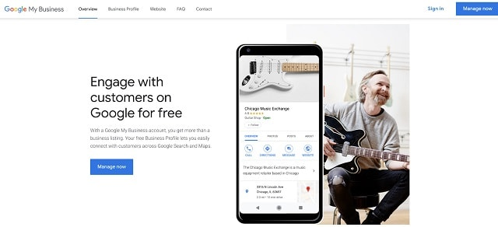

There are a handful of online business directory listings that you could potentially list your business on. A recommended way to approach this advertising method is to first list your business on the major sites (Google, Yelp, YP, etc.) and then hand-pick a few more that are relevant to web design.

**Editor’s note:** Want an easy way to manage all your online business listings? Check out [GoDaddy Local Business Listings](https://www.godaddy.com/online-marketing/local-business-listings?sp_hp=B&xpmst=A&xpcarveout=B" \t "_blank), a service that enables you to manage all your listings from one convenient dashboard.

Other sites worth listing your web design business are [Thumbtack](https://www.thumbtack.com/) and [Angie’s List](https://www.angieslist.com/), as they provide an excellent directory listing platform that allows you to be found by customers that are directly looking for a business like yours online.

You can also [send a proposal](https://www.godaddy.com/garage/how-to-create-freelance-quotes-and-proposals-dos-and-donts/) right from the site. This makes it easy to organize all of your online leads and proposals, and even [collect feedback and reviews](https://www.godaddy.com/garage/how-to-ask-for-testimonials-and-reviews-from-your-clients/) once projects are completed.

[**Back to top**](https://www.godaddy.com/garage/advertising-web-design-development-business/#top)

**Diversify your clientele by advertising on websites for freelance projects**

Want to expand your services beyond just local projects?

**Websites for freelance projects are a great opportunity to expand your services nationally and even globally by bidding on web design projects from around the world.**

There are a variety of websites where clients can post the scope of their web design projects and allow a number of freelancers to bid on the project based on the cost, timeline, scope and reputation of the freelancer.

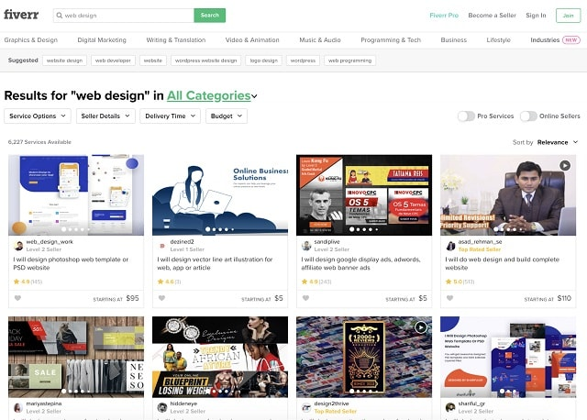

A great benefit of these sites is that they allow you to browse through hundreds of web design projects and see details about the scope and requirements of a project before you decide to take them on.

Depending on the site you decide to use, you can also check a client’s reviews to decide if they are someone you’d want to work with.

However, one downside of this method is sites like Upwork often take a small [percentage of your overall project cost](https://support.upwork.com/hc/en-us/articles/211062538-Freelancer-Service-Fees).

**Here are a few web design freelance websites to look into:**

* [Upwork](https://www.upwork.com/)
* [Fiverr](https://www.fiverr.com/)
* [Simply Hired](https://www.simplyhired.com/)
* [PeoplePerHour](https://www.peopleperhour.com/)
* [DesignHill](https://www.designhill.com/)

One thing to keep in mind about projects from freelance websites is that this can be an inconsistent stream of projects, as the needs of every client highly vary, as do their budgets and expectations.

It is a good idea to use freelance websites as a supplement to other advertising strategies.

[**Back to top**](https://www.godaddy.com/garage/advertising-web-design-development-business/#top)

**Pair your website with SEO for a strong advertising strategy**

In a highly competitive industry like web design and development, your business website is one of the most important tools you can leverage when it comes to advertising. Thus, it’s important to make sure that your website is well-rounded in terms of having an in-depth [project portfolio](https://www.godaddy.com/garage/web-design-portfolios/) that shows your work and past projects.

Your business website should also show potential clients what your skills are and accurately portray the quality of work they can expect to get by working with you.

After you’ve taken the time to build your business website, it’s time to optimize it using [SEO (search engine optimization) best practices](https://www.godaddy.com/garage/seo-best-practices-for-your-website/).

**SEO is a great way to advertise your web design services without needing to spend too much money.**

The more time you take to boost your website’s SEO value, the more search engines like Google and Bing will show your website in relevant search results for your business.

There are many guides and tools that can help you make your SEO better, but generally, it all starts with making sure your website is regularly updated with fresh new content and updates.

Regular [blog posts and updates](https://www.godaddy.com/garage/blog-seo-tips/) will signal sites like Google that your website is actively maintained and will show your website higher on relevant search results. Once you’ve published your blogs on your website, you can share them on social media to get even more people to your website.

To get the ball rolling, start by writing blog posts that recap recent projects you completed. Include photos and screenshots of the completed work, and talk about some of the challenges and creative process. This will make your blog posts interesting and will position you as a subject matter expert in your field.

Make sure to share the completed posts with your clients and ask that they share it on their own social media pages for an extra traffic boost.

*Related:*[*Roundup of SEO resource*s](https://www.godaddy.com/garage/seo-for-business-resources/)

[**Back to top**](https://www.godaddy.com/garage/advertising-web-design-development-business/#top)

**Generate offline leads by advertising through business relationships**

Who says that the internet is the only place where you can advertise your business? Sometimes, it’s a good idea to supplement your advertising strategy with strong business relationships that can lead to more clients from word of mouth.

There are many ways to build business relationships that could lead to increased business, and most of them don’t take much except some well worth the time and effort.

In fact, the power of word of mouth advertising is so strong that according to Nielsen, [92% of people trust recommendations from friends and family more than they do advertising](https://www.nielsen.com/us/en/insights/report/2012/global-trust-in-advertising-and-brand-messages-2/).

**One way to build business relationships is by meeting local business owners that might need your business and introducing your services to them.**

Remember, business owners are busy, so try to stay away from pitching services. Instead, make yourself available as a resource for anything they might need related to your services.

A good method is to offer to meet with them for a free consultation to cover recommended improvements on their business website. Most owners will be open to the advice and could end up wanting to hire you to implement the suggested changes. At worst, they’ll keep your business card and possibly give you a referral down the road.

*Related:*[*How to market a local business through strategic collaboration*](https://www.godaddy.com/garage/how-to-market-a-local-business-through-strategic-collaboration/)



Trade shows and industry events can also be a great source of clients, as long as you have the time and money to invest in it. While these events can sometimes be expensive, the return on your investment could pay off if you walk away even with one client secured.

**Here are some things to consider before you decide to take your business to a trade show or industry event:**

**Check for roaming exhibitor passes**

Booths and tables can be expensive. Check to see if the event offers a roaming exhibitor pass so that you can freely hand out your business card and talk about your services without paying the full price of a booth.

**Do your research**

What kind of people will be at this event? Are they in the same category as the type of clients you’re looking for? Will decision-makers be there or managers? You will want to make sure your target clientele will be there before you spend the money.

**Collect as many business cards as you can**

You can later create a contact list and send your newly found contacts a monthly newsletter talking about your services and recently completed projects.

**Consider a geo-fence ad instead**

This is a trick that not many people know but is highly effective. Consider creating a Facebook ad for your services targeted to an area that’s within five miles of the conference center on the date(s) of the event to get awareness for your business. More on this strategy can be found [here](https://pnmg.com/geofencing-retargeting-reaching-target-audience/).

*Related: [WordCamps and the WordPress community](https://www.godaddy.com/garage/wordcamps-the-wordpress-community/" \t "_blank)*

[**Back to top**](https://www.godaddy.com/garage/advertising-web-design-development-business/#top)

**Go old school with referrals and print advertisements**

Speaking of referrals, this is a tactic that you can implement immediately to start advertising your web design business.

**Your existing customers are a large network of business connections just waiting to be tapped into.**

Think of an incentive you could offer your existing clients for their referrals, and before you know it you’ll have them doing most of the work for you. Remember, word of mouth is a highly effective advertising tool, so referrals could easily become one of your strongest advertising methods for your web design services.

Another business relationship building idea that is often overlooked is the tried-and-true method of printing out business cards or flyers to hang up (with permission) and pass around your local neighborhood businesses.

As I’ve mentioned already, business owners are busy and don’t have much time, especially when it comes to making improvements to their business website. If a business owner conveniently finds your flyer or business card at a local coffee shop, it is more convenient to call you about your services then it is to go searching online through thousands of other web design services.

It may sound old school and outdated, but very few people are doing this to advertise their web design services nowadays and it’s truly a missed opportunity!

*Related:*[*How to ask for referrals as a web designer*](https://www.godaddy.com/garage/how-to-ask-for-referrals-as-a-web-designer-and-what-to-do-when-it-doesnt-work/)

[**Back to top**](https://www.godaddy.com/garage/advertising-web-design-development-business/#top)

**Start advertising your web design & development business**

A strong advertising campaign does not need to be complicated, fancy or expensive. It should work for your business in a way that can sustainably bring you a steady stream of new projects and clients that match the skills and services your web agency provides.

**To recap, here are the web design promotion ideas we’ve covered:**

* Tap into a larger network on social media.
* Laser-target your customers with paid advertising.
* Be everywhere with online local business directory listings.
* Diversify your clientele by advertising on websites for freelance projects.
* Pair your website with SEO for a strong advertising strategy.
* Generate leads offline by advertising through business relationships.

It can take some time to find the right mix of tactics, so take your time and be patient. Keep your mind open to new strategies and remember to always keep trying new ways to advertise your web agency.

I recommend starting by ensuring that your social media presence is active and getting a solid business website with an in-depth portfolio up and running, as these are core elements of any successful advertising campaign.

After you’ve implemented some of these promotion strategies and those new clients start piling up, you’ll need better tools to keep track of it all. Save time with free tools and resources built just for web designers & developers. [**Join GoDaddy Pro for free**](https://www.godaddy.com/pro)**.**